Assignment 12  
Chaiwat Plongkaew 2021326660023

P1. Suppose the information content of a packet is the bit pattern 1110 0110 1001 0101 and an even parity scheme is being used. What would the value of the field containing the parity bits be for the case of a two-dimensional parity scheme? Your answer should be such that a minimum-length checksum field is used.  
Ans  
The minimum length checksum field should be 4*4 matrix. For our data, two dimensional (even) parity:

|  |  |  |  |  |
| --- | --- | --- | --- | --- |
| 1 | 1 | 1 | 0 | 1 |
| 0 | 1 | 1 | 0 | 0 |
| 1 | 0 | 0 | 1 | 0 |
| 0 | 1 | 0 | 1 | 0 |
| 0 | 1 | 0 | 0 | 1 |

P5. Consider the 5-bit generator, G = 10011, and suppose that D has the value 1010101010. What is the value of R?  
Ans  
  
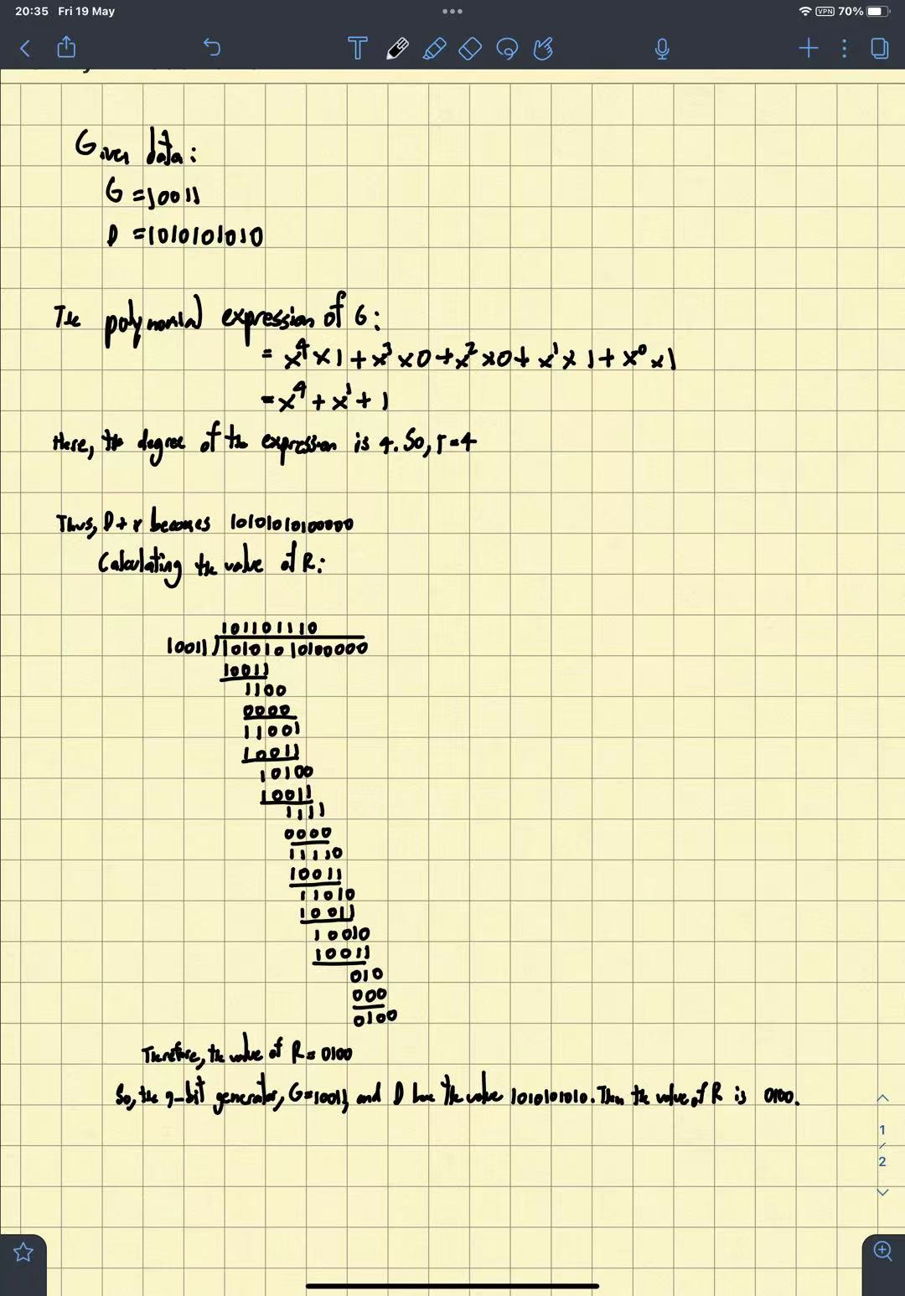  
  
P17. Recall that with the CSMA/CD protocol, the adapter waits K # 512 bit times after a collision, where K is drawn randomly. For K = 100, how long does the adapter wait until returning to Step 2 for a 100 Mbps broadcast channel? For a 1 Gbps broadcast channel?  
Ans

Wait for 51200 bit times. For 100 Mbps, this wait is   
51.2 x 10^3 bits : 10 X 10^7 bps = 8 / 15625 = 0.000512 = 512 µsec

For 1Gbps, 51.2 x 10^3 bits : 10 X 10^9 bps = 2 / 390625 = 5.12 X 10^-6 = 0.00000512 = 5.12 µsec  
  
  
P19. Suppose nodes A and B are on the same 10 Mbps broadcast channel, and the propagation delay between the two nodes is 245 bit times. Suppose A and B send Ethernet frames at the same time, the frames collide, and then A and B choose different values of K in the CSMA/CD algorithm. Assuming no other nodes are active, can the retransmissions from A and B collide? For our purposes, it suffices to work out the following example. Suppose A and B begin transmission at t = 0 bit times. They both detect collisions at t = 245 t bit times. Suppose KA = 0 and KB = 1. At what time does B schedule its retransmission? At what time does A begin transmission? (Note: The nodes must wait for an idle channel after returning to Step 2—see protocol.) At what time does A’s signal reach B? Does B refrain from transmitting at its scheduled time?  
Ans

**Consider the following data:**  
Rate of the broadcast channel = 10 Mbps

Propagation delay between two nodes = 245 bit times  
Node A and node B detect collision at time t = 245 bit times

Node A and node B choses random values, KA = 0 and KB = 1, respectively

**Node B retransmission:**

* Node A and B both starts transmission at t = 0 bit times.
* A and B detects the collision at t = 245 bit times. That is, already A and B sent 245 bits into Ethernet.
* Now, both nodes stop the transmission and issues a jam signal for 48 bit times.
* So, jam signal ends at t = 245 + 48 = 293 bit times.  
  Then, both nodes enter exponential backoff phase and chooses random values, KA = 0 and KB = 1, respectively.
* Since B selects random value KB =1, it must wait KB x 512 = 1 X 512 = 512 bit times. After 512 bit times, that is at t = 293 + 512 = 805 bit times, node B returns to step2
* Before transmitting frame, node B must sense channel for 96 bit times. Thus, node B schedules its retransmission at t = 805+96 = 901 bit times
* **Therefore, node B begin transmission at time t = 901 bit times.**

**Node A starting transmission:**

* Since node A selects random value KA = 0 and thus random waiting time is KA X 512 = 0 X 512 = 0 bit times.
* After jam signal ends )at t=293 bit times), node A returns to step 2 without waiting for retransmission.
* Before transmitting frame, node A must sense the channel 96 bit times. But the channel is still busy since the node B already sent 245 bits into Ethernet and they are on the way. The last bit sent by node B reaches the node A at t = 245 + 48 + 245 = 538 bit times.
* At t = 538 bit times, node A senses the channel for 96 bit times and detects an idle channel at t = 538+96 = 634 bit times and starts sending frame.
* **Therefore, node A begins transmission at time t = 634 bit times.**

The propagation delay, that is the time required by a signal sent by node A to reach node B is 245 bit times.

The signal from node A reaches node B at time t = 634 + 245 = 879 bit times.

**Therefore, node A’s signal reaches node B at time t = 879 bit times.**  
  
Since B selects random value KB = 1, it must wait KB X 512 = 1 X 512 = 512 bit times. After 512 bit times, that is at t = 293 + 512 = 805 bit times, node B returns to step2 and schedules its retransmission.

* After entering Step2, node B senses the channel at t = 805 bit times, for 96 bit times. That is, node B must wait until t = 805 + 96 ==901 bit times.
* Since 879 < 901, node B detects the signals sent by node A at t = 879.
* As a result, node B refrains from transmitting at its scheduled time.

**Since node B receives a signal sent by node A before its scheduled retransmission time, node B refrains from transmitting until node A finishes its transmission.**

**Since the retransmission of node A reaches node B before its scheduled retransmission time, node B refrains from transmitting frames until node A finishes its transmission.**

**Thus, transmission from node A and node B do not collide with each other. So, the factor 512 bit times, mentioned in the exponential algorithm is sufficiently large.**